Kitch-iti-Kipi?
Use the Michigan Upper Peninsula Guide to answer the following questions.
- What is Kitch-iti-Kipi?

- Find the ‘COUNTY’ for the following fun activities:
  - Oswald’s Bear Ranch __________________________________
  - Eagle Harbor Lighthouse _______________________________
  - Drummond Island ____________________________________
  - More than 100 waterfalls ______________________________
  - Glass bottom Shipwreck Tours ___________________________
  - U.P. Championship Rodeo ______________________________
  - Presque Isle Park _____________________________________

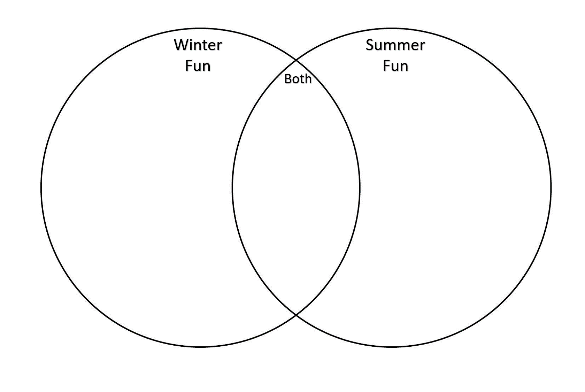
- Complete the Venn Diagram using the ‘RECREATION’ tab:

- Use the website to create a few of your own questions for classmates.
  - Question 1:

  - Question 2:

  - Question 3:

