Title: What is the Difference between a Solar Eclipse and a Lunar Eclipse?
Student Sheet
- Examine the diagrams. One shows a solar eclipse. The other shows a lunar eclipse. Answer the following questions:
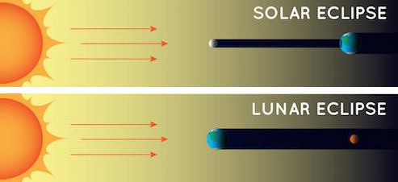
Solar and Lunar eclipse diagrams, Diagrams not to scale, Credit: NASA Space Place, https://mynasadata.larc.nasa.gov/sites/default/files/inline-images/Solar%20and%20lunar%20eclipse.png
  - What are the similarities between these two types of eclipses?

  - What are the differences between these two types of eclipses?

  - Which object casts a bigger shadow, Earth or the Moon?

  - Which eclipse could more people on Earth experience at the same time? Support your claim with evidence and reasoning.

- Predict:
  - Which image is of a solar eclipse taken from Earth? Which image is of a lunar eclipse taken from Earth?
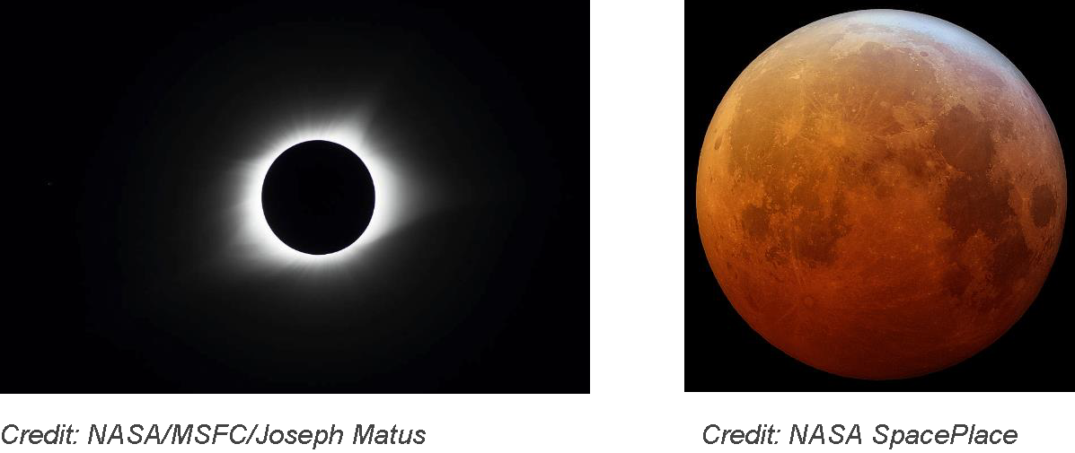
  - Record your observations about each image.

https://mynasadata.larc.nasa.gov/sites/default/files/inline-images/eclipse%20images.png

Solar Eclipse | Lunar Eclipse

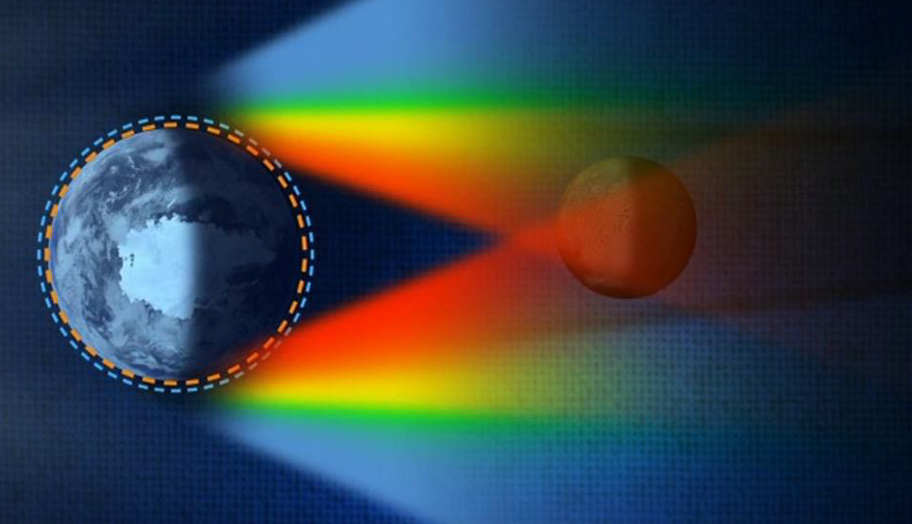
- Why does the Moon look the way it does during a lunar eclipse?

Credit: NASA Goddard Space Flight Center/Scientific Visualization Studio *This image is not to scale. https://mynasadata.larc.nasa.gov/sites/default/files/inline-images/solar%20and%20lunar%20eclipses.png
- Why does the Moon appear red during a lunar eclipse?

- What is another example of Earth’s atmosphere scattering sunlight?

- Why does the Sun look the way it does during a total solar eclipse?
During a total solar eclipse, the disk of the Moon blocks out the bright light of the photosphere. This exposes the Sun’s atmosphere, or the corona. The corona can only be seen during a total solar eclipse, or using special equipment, like NASA has.

Examine the Mind-Melting Facts about the Sun graphic and text found at https://www.nasa.gov/mission_pages/sunearth/the-heliopedia, and answer the following questions:
- Which layer of the Sun is normally visible, on a bright, sunny day?

- Why are scientists so interested in viewing the corona - what is the “Puzzle of Coronal Heating”?

- Model: What objects could you use to model a solar eclipse and a lunar eclipse? Draw your plans for each model.
​

